Subject : | Programming For Ai
Name : | Aman Ali
Roll No : | 195
Class : | BSAI
Section : | 4C
Submission Date : | Saturday, March 7, 2026

W Sentiment Analysis System Using VADER

1. Introduction
Sentiment Analysis is a Natural Language Processing (NLP) technique used to determine the emotional tone of text. It helps identify whether a sentence expresses a positive, negative, or neutral opinion. This technique is widely used in many real-world applications such as product reviews, social media monitoring, customer feedback analysis, and opinion mining.
In this project, a simple Sentiment Analysis System was developed using the VADER (Valence Aware Dictionary and Sentiment Reasoner) model. VADER is a rule-based sentiment analysis tool that is specially designed for analyzing text from social media and general English sentences.
The system analyzes a given sentence and calculates four sentiment scores:
- Positive score
- Negative score
- Neutral score
- Compound score
The compound score is then used to determine the overall sentiment of the sentence.

2. Objective of the Project
The main objective of this project is to build a simple program that can analyze text and determine its sentiment automatically.
The goals of this project include:
- Understanding the basic concept of Sentiment Analysis
- Learning how to use a pretrained NLP model
- Implementing sentiment analysis using Python
- Creating a small interactive program where users can test their own sentences

3. Why VADER was Used
VADER was selected for this project because it is simple, fast, and effective for short text analysis.
Some advantages of VADER include:
- It is pretrained, so no training dataset is required
- It works well on short sentences and social media text
- It provides multiple sentiment scores
- It is easy to integrate with Python programs
Because of these advantages, VADER is commonly used for beginner NLP projects and demonstrations.

4. Tools and Technologies Used
The following tools were used to develop this project:
- Python – Programming language used to implement the program
- VADER Sentiment Analyzer – Library used to analyze sentiment
- Virtual Environment – Used to manage project dependencies
- VS Code / Python IDE – Used for writing and running the code

5. Project Setup
Before running the program, the required dependencies must be installed.

5.1 Creating a Virtual Environment
A virtual environment helps keep project dependencies separate from the main system.
Create the virtual environment:
python -m venv sentiment_env
Activate the virtual environment:
Windows
sentiment_env\Scripts\activate
Linux / Mac
source sentiment_env/bin/activate

5.2 Installing Dependencies
A requirements.txt file can be used to install all dependencies automatically.
Example requirements.txt
vaderSentiment
Install dependencies using:
pip install -r requirements.txt

6. System Workflow
The working process of the program is simple and consists of the following steps:
- The user selects an option from the program menu.
- The program can either run demo examples or accept custom user input.
- The input sentence is passed to the VADER sentiment analyzer.
- VADER calculates sentiment scores.
- The program prints the sentiment scores and determines the overall sentiment.

7. Program Features
The program includes the following features:
- Demo mode to analyze predefined sentences
- User input mode to analyze custom sentences
- Clear display of sentiment scores
- Classification of overall sentiment
- Simple menu-based interaction

8. Demo Execution
The program includes a demo function that analyzes predefined sentences.
Example sentences used in the demo include:
- Geeks For Geeks is an excellent platform for CSE students.
- I am feeling sad today.
- Artificial Intelligence is changing the world in amazing ways.
- The movie was terrible and I regret watching it.
- Today is Monday and I have a class at 9 AM.
Each sentence is analyzed and classified as positive, negative, or neutral.

9. Example Output
Example program output:
Sentence: I am going to destroy the entire city by using Ai.
Negative: 25.90%
Neutral: 74.10%
Positive: 0.00%
Overall Sentiment: Negative
This output shows that the system successfully detects negative sentiment due to the presence of a destructive word such as “destroy.”

10. Screenshot of Program Output
Insert the screenshot of the program execution here.
Example:
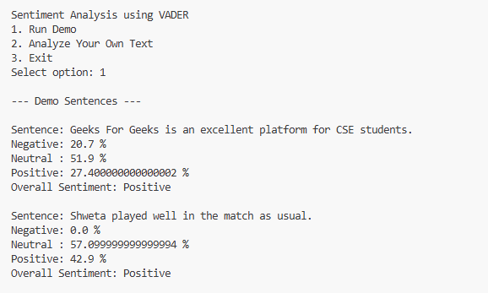
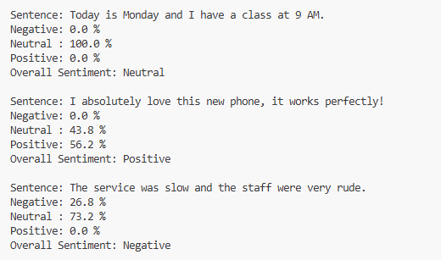

11. Limitations of the System
Although the system works well for basic sentences, it has some limitations:
- It may not fully understand sarcasm or irony
- It works best with short English sentences
- It does not perform deep contextual understanding like advanced transformer models
However, it is still effective for simple sentiment analysis tasks.

12. Final Thoughts
This project successfully demonstrates the implementation of a simple Sentiment Analysis System using VADER. The program can analyze sentences and determine whether they express positive, negative, or neutral sentiment.
The project also helped in understanding the basic concepts of Natural Language Processing and sentiment classification. Because of its simplicity and effectiveness, VADER provides a good starting point for learning sentiment analysis.
In the future, the system can be improved by integrating machine learning models or deep learning approaches to handle more complex text data.

